IOT Analytics Project 2

# Task 1. Basic statistics analysis

1.1. For each variable Xi, i.e. column in the data set corresponding to Xi, calculate the following: Histogram, mean, variance.

1.2 Calculate the correlation matrix Σ among all variables, i.e., Y, X1, X2, X3, X4 and X5. Draw conclusions related to possible dependencies among these variables.

1.3 Comment on the results

**Solutions**

* 1. Following is histogram (with 10 bins), mean and variance output generated from the python code

X1 Statistics

Mean: 290.124089121

Variance: 20950.37758

Histogram:

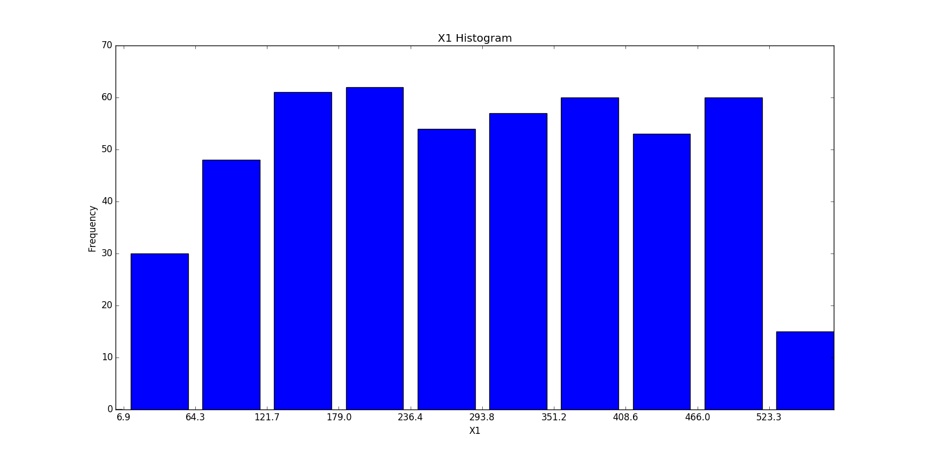

**Comments:**

The X1 predictor values have almost a uniform distribution across the range 6.88-580.72. Hence variance is also high

X2 Statistics

Mean: 3.55

Variance: 2.7795

Histogram:

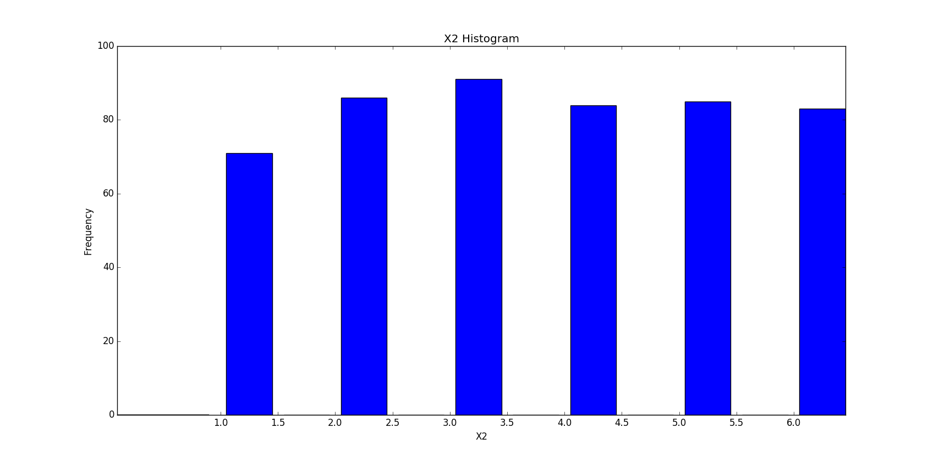

**Comments:**

X2 values show a uniform distribution across the range 1-6 (It takes only integer values in the range 1-6)

X3 Statistics

Mean: 0.0961538665037

Variance: 0.00850874896488

Histogram:

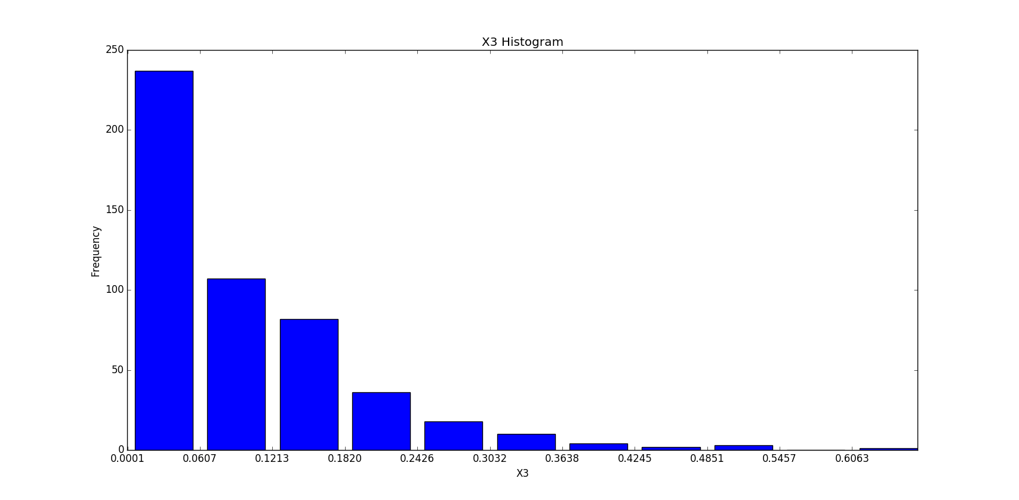

**Comments:**

X3 shows a decreasing frequency towards the higher values in the range 0.000092-0.606

X4 Statistics

Mean: 153.82

Variance: 14542.4076

Histogram:

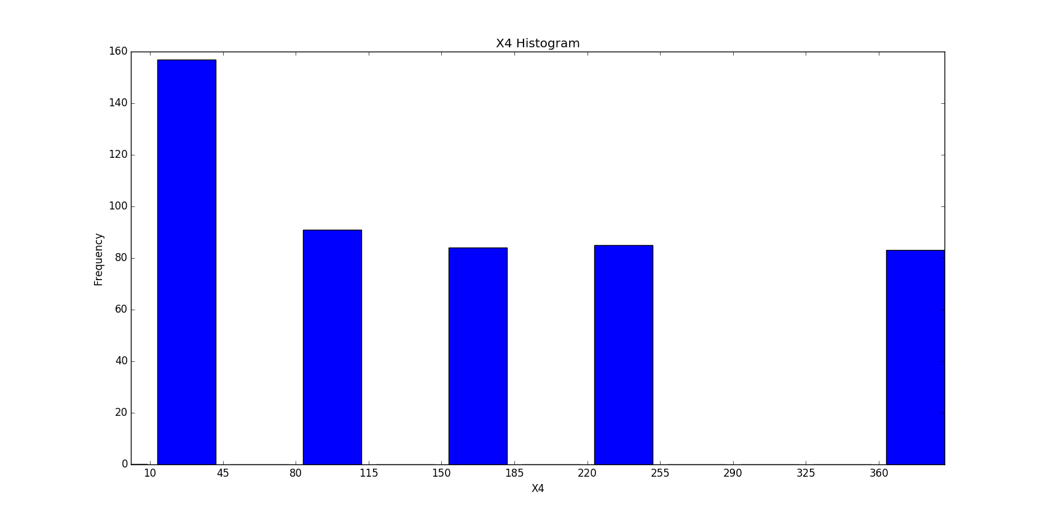

**Comments:**

X4’s distribution looks to be concentrated at uniform intervals. The values lie in the range 10-360. Hence variance is also high

X5 Statistics

Mean: 2.94755715125

Variance: 12.4413830852

Histogram:

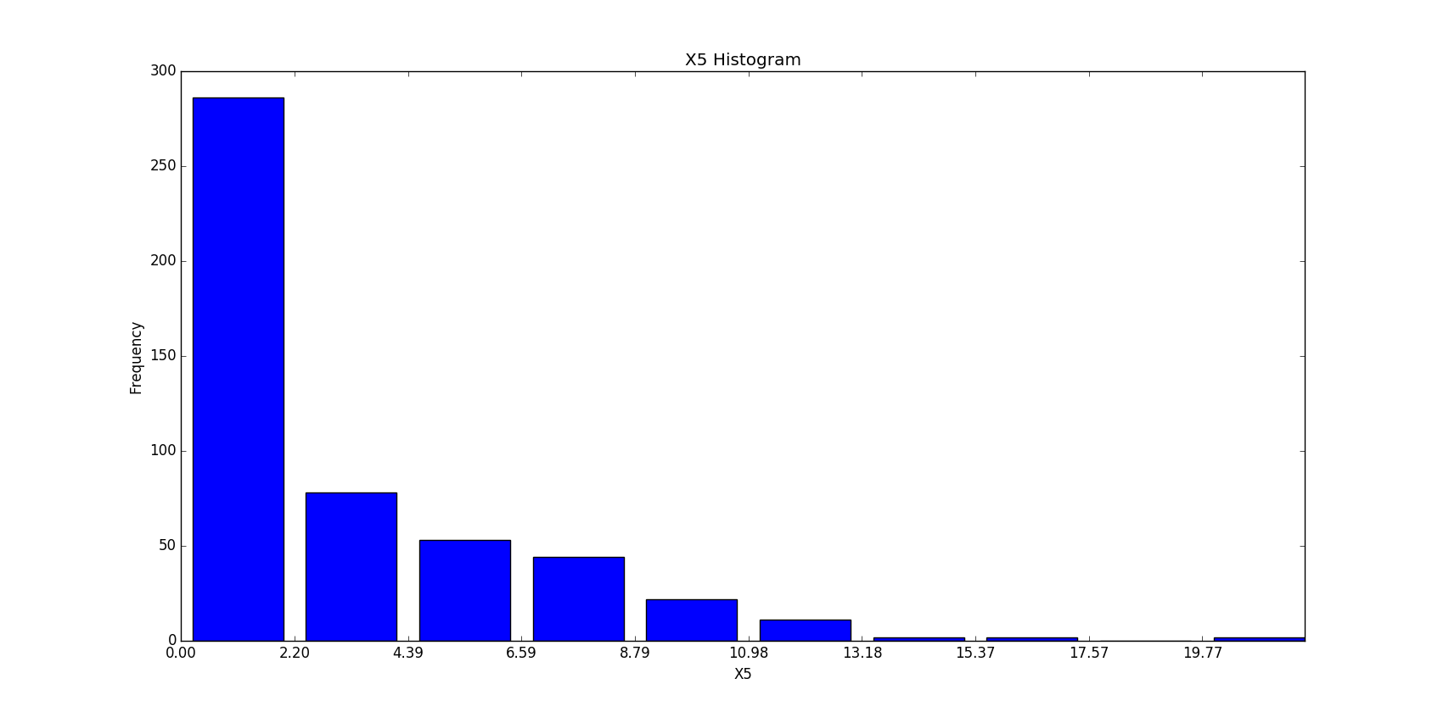

**Comments:**

The frequency of X5 is decreasing towards the higher values in the range 0-21.96

* 1. Correlation matrix Σ among all variables, i.e., Y, X1, X2, X3, X4 and X5. Draw conclusions related to possible dependencies among these variables.

**Solution**

Correlation Matrix

X1 X2 X3 X4 X5 Y

X1 1.000000 -0.028226 0.008334 -0.030691 0.808730 0.594091

X2 -0.028226 1.000000 0.014436 0.979061 -0.003626 0.769769

X3 0.008334 0.014436 1.000000 0.004659 -0.002230 0.009335

X4 -0.030691 0.979061 0.004659 1.000000 -0.005422 0.784811

X5 0.808730 -0.003626 -0.002230 -0.005422 1.000000 0.506689

Y 0.594091 0.769769 0.009335 0.784811 0.506689 1.000000

Pictorially it can be represented as

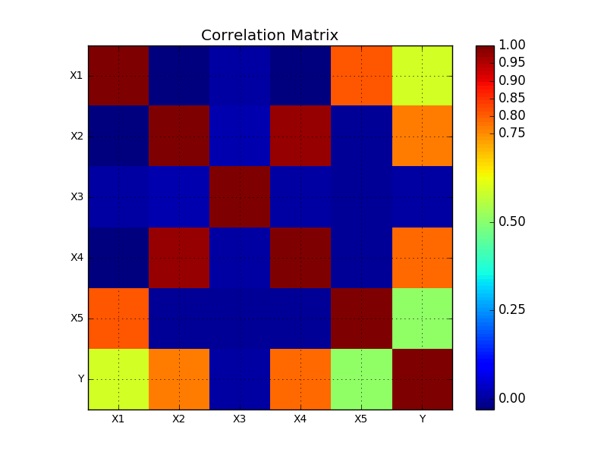

**Conclusions:**

As can be clearly seen from the matrix,

There is a high correlation between X1 and X5 (0.808).

Similarly, X2 and X4 have a very high correlation of 0.97

All variables are weakly correlated with X3. As a matter of fact, X3 is also not correlated with Y.

Regarding correlation with Y, all independent variables except X3 have a fairly high (> 0.5) correlation with Y. X3 and Y are highly uncorrelated. So, Y does not show dependence on X3.

It is also obvious that all variables are 100% correlated with themselves.

* 1. Overall Comments

Here is a quick statistical summary of all the variables.

X1 X2 X3 X4 X5 \

count 500.000000 500.000000 500.000000 500.000000 5.000000e+02

mean 290.124089 3.550000 0.096154 153.820000 2.947557e+00

std 144.887413 1.668853 0.092335 120.712678 3.530767e+00

min 6.888046 1.000000 0.000092 10.000000 2.023632e-18

25% 167.161179 2.000000 0.028700 40.000000 2.410634e-01

50% 291.101319 4.000000 0.067882 160.000000 1.366149e+00

75% 410.419896 5.000000 0.136746 250.000000 4.909353e+00

max 580.721180 6.000000 0.606321 360.000000 2.196329e+01

Y

count 500.000000

mean 1514.667647

std 675.695478

min 171.257672

25% 1003.640591

50% 1500.081343

Comments on correlation matrix:

We observe that X3 is not correlated with Y. Considering very less dependency of Y on X3, we should exclude it when predicting the value of Y (when doing Multiple linear regression). When included, it may result in the case of overfitting.

Also, X3 shows minimal correlation with other independent variables X1, X2, X4 and X5 which makes it a good candidate for zero contribution to multi-collinearity when performing multivariate linear regression. We will analyze it more in the third task discussed below.

We also, see that the independent variables, X1, X2, X4 and X5 are highly correlated with Y. Hence, they are good candidates for predictor variables. But there is a high correlation between X1 and X5 and also X2 and X4 which can result in multicollinearity problem

We will analyze the effect in task 3 below

Comments on Y distribution: Y has a high mean. It is much likely that it has only positive correlation with predictor variables. Also, on plotting Y’s histogram, it looks close to a normal distribution

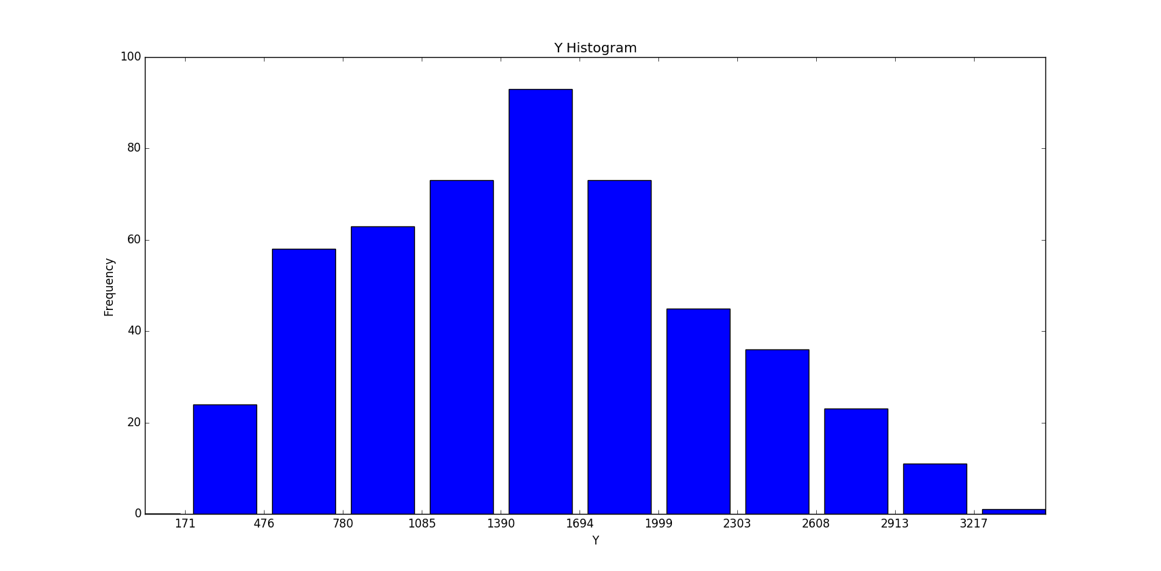

# Task 2: Linear regression

Before proceeding with the multiple regressions, you will carry out a simple linear regression to estimate the parameters of the model: Y = a0 + a1X + ε, where X = X1.

2.1 Determine the values for a0, a1, and s2.

2.2 Check the p-values, R2, F value to determine if the regression coefficients are meaningful.

2.3 Plot the regression line against the data.

2.4 Do residuals analysis:

a. Do a Q-Q plot of the pdf of the residuals against N (0, s2) Alternatively, draw the residuals histogram and carry out a χ 2 test that it follows the N (0, s2).

b. Do a scatter plot of the residuals to see if there are any correlation trends.

2.7 Use a higher-order polynomial regression, i.e., Y = a0 + a1X + a2X2 + ε, to see if it gives better results.

2.8 Comment on your results in a couple of paragraphs.

**Solutions**

**2.1** This was achieved using the python functions written in project_P2.py as submitted and it was verified using the scipy and pandas.stats library in python

Slope (a1) =2.77059784726, intercept (a0) = 710.850469793

s2 = 294831.701777

**2.2** R2 = 0.352944381494

F-Value = 271.640175832

p-value = 5.0366022946e-49 = 0(approximately)

Quick summary of Regression Analysis for X1 using pandas.stats library

-------------------------Summary of Regression Analysis-------------------------

Formula: Y ~ <X1> + <intercept>

Number of Observations: 500

Number of Degrees of Freedom: 2

R-squared: 0.3529

Adj R-squared: 0.3516

Rmse: 544.0733

F-stat (1, 498): 271.6402, p-value: 0.0000

Degrees of Freedom: model 1, resid 498

-----------------------Summary of Estimated Coefficients------------------------

Variable Coef Std Err t-stat p-value CI 2.5% CI 97.5%

--------------------------------------------------------------------------------

X1 2.7706 0.1681 16.48 0.0000 2.4411 3.1001

intercept 710.8505 54.5035 13.04 0.0000 604.0237 817.6772

---------------------------------End of Summary---------------------------------

**Comments:**

R2 value is around 0.3529 which is low in order to ensure goodness of the model to fit the data. Low R shows there is more scatter around the regression line. So it is possible that if we add more predictor variables to predict Y value, the model may fit better.

P value corresponding to the F-test is 0.000 which is significant (considering 0.025 as the cutoff for significance) enough to state that our model provides a better fit than intercept only model. So X1 is a meaningful addition. Higher F value and low p would mean a meaningful predictor

When considering p value of X1 we find that it is low (around 0), which implies good variability of the response variable (Y) with changing X1. So there is a good relationship between X1 and Y. So, predictor X1 is a meaningful addition to our model.

**2.3 Regression Line is shown in the following figure**

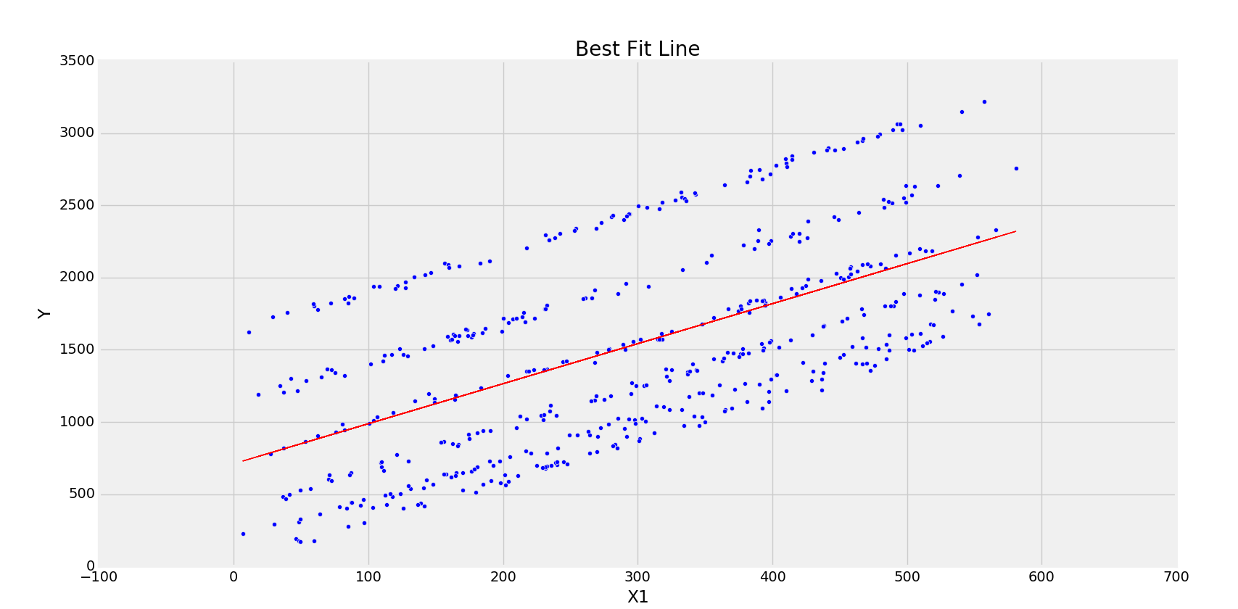

Comments: As can be seen and also as analyzed above, the line has a lot of scatter around it which accounts for a small R_squared value

**2.4 Residual Analysis**

In residual analysis, we observe the residual values distribution and will assess that the residuals are consistent with stochastic errors. It implies that the residuals should not be either symmetrically high or low. So their average should be zero throughout the range of fitted values. Also, the residuals are assumed to be normally distributed in ordinary least squares context.

Any non-randomness in residuals implies that the deterministic portion (predictor variables) of the model is not capturing some information that may be leaking into the residuals.

In addition, the residuals should not be correlated with any predictor variables and also not auto-correlated.

**2.4 (a)**

Q-Q plots of the residuals

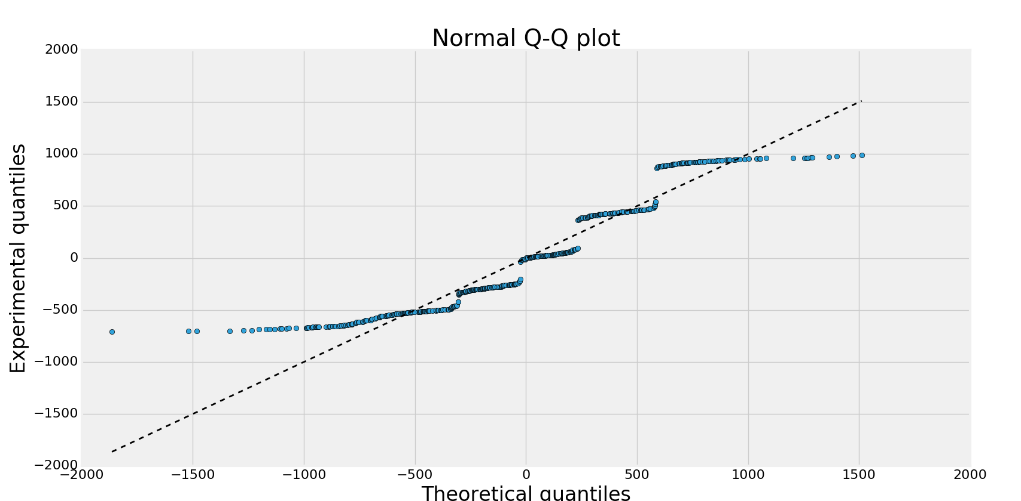

As can be seen, the distribution of residuals is close to the normal distribution line but it has tails and high modality. There are multiple breaks (camel humps like structure) in residual when compared with a normal distribution (shows a multi modal behavior). So, residuals distribution here doesn’t resemble a normal distribution perfectly.

Comparing the normal distributions histograms

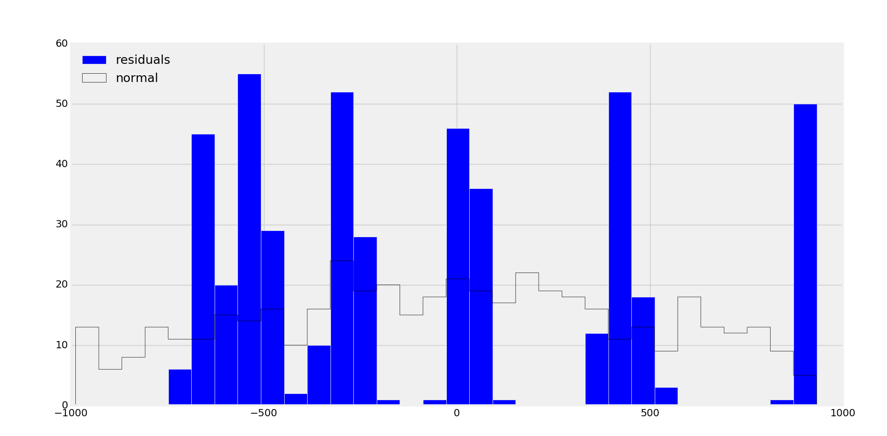

Normal distribution for the residuals is very discontinuous (multi-modal) and is not a perfect representation of the normal distribution N(0,s2)

We perform the chi-square test on these two histograms data

H0: the data are normally distributed

Ha: the data are not normally distributed

From the program and using scipy library, the calculated chi_square with 32 bins value is

X2 = 1121.23323618

Calculating critical value for chi_square statistics with

X2_crit = 42.557

Since X2 > X2_crit, we can reject the hypothesis, and know that the residual data is not normally distributed

**2.4(b)**

Scatter plots of residuals with X1

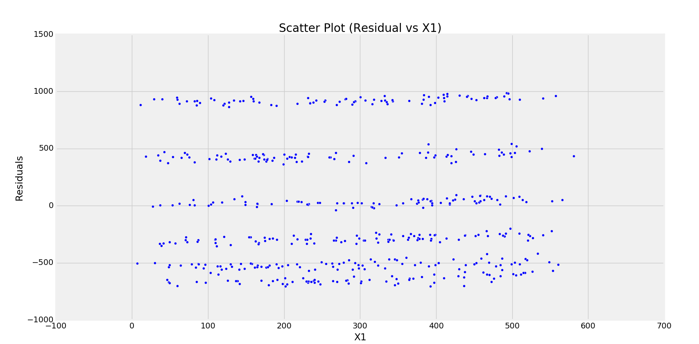

Scatter plot of residuals with Yfit (best fit values)

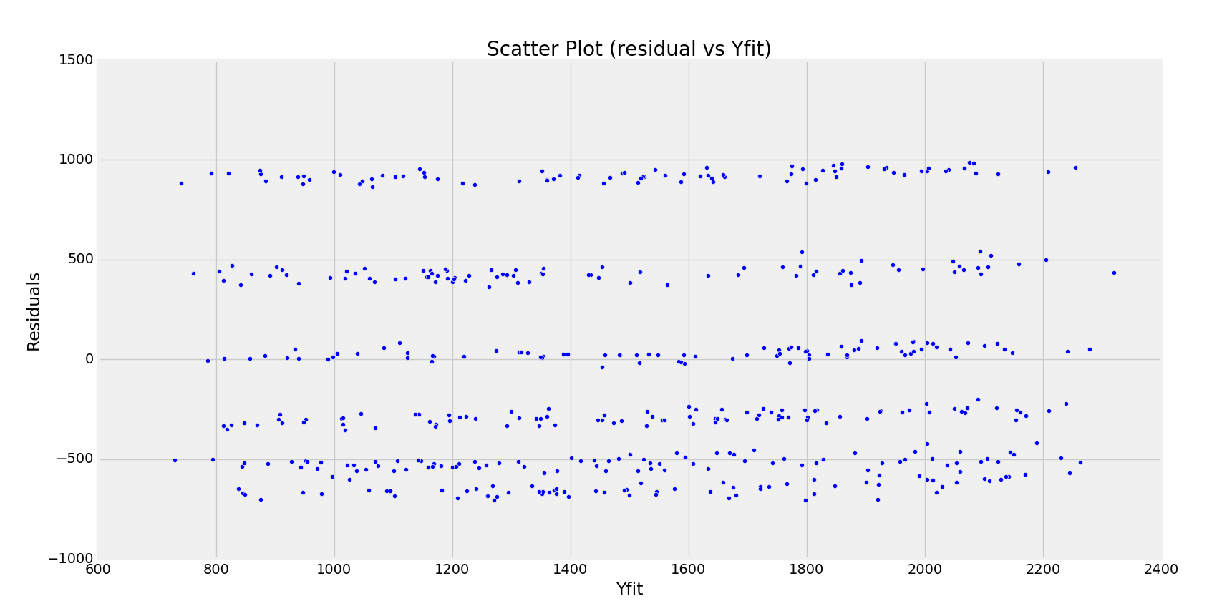

Comments:

From the scatter plot, it can be seen that the residuals average out to zero value and they have no correlation with the X1 and predicted values. X1 is a good candidate for the model

**2.7 Analysis using higher order polynomial**

Summary of univariate linear regression with order 2

-------------------------Summary of Regression Analysis-------------------------

Formula: Y ~ <X1_sq> + <X1> + <intercept>

Number of Observations: 500

Number of Degrees of Freedom: 3

R-squared: 0.3542

Adj R-squared: 0.3516

Rmse: 544.1052

F-stat (2, 497): 136.2750, p-value: 0.0000

Degrees of Freedom: model 2, resid 497

-----------------------Summary of Estimated Coefficients------------------------

Variable Coef Std Err t-stat p-value CI 2.5% CI 97.5%

--------------------------------------------------------------------------------

X1_sq 0.0012 0.0012 0.97 0.3323 -0.0012 0.0036

X1 2.0799 0.7314 2.84 0.0046 0.6463 3.5134

intercept 785.4800 94.2628 8.33 0.0000 600.7248 970.2351

---------------------------------End of Summary---------------------------------

We can observe that the R squared value has not changed much from the 1st order simple linear regression. Also, the standard error for X1 has increased significantly. P-value for X1_sq coefficient is high and implies that including X1_sq coefficient is not better than the model with just X1 and intercept

Graphically also, the model doesn’t improve

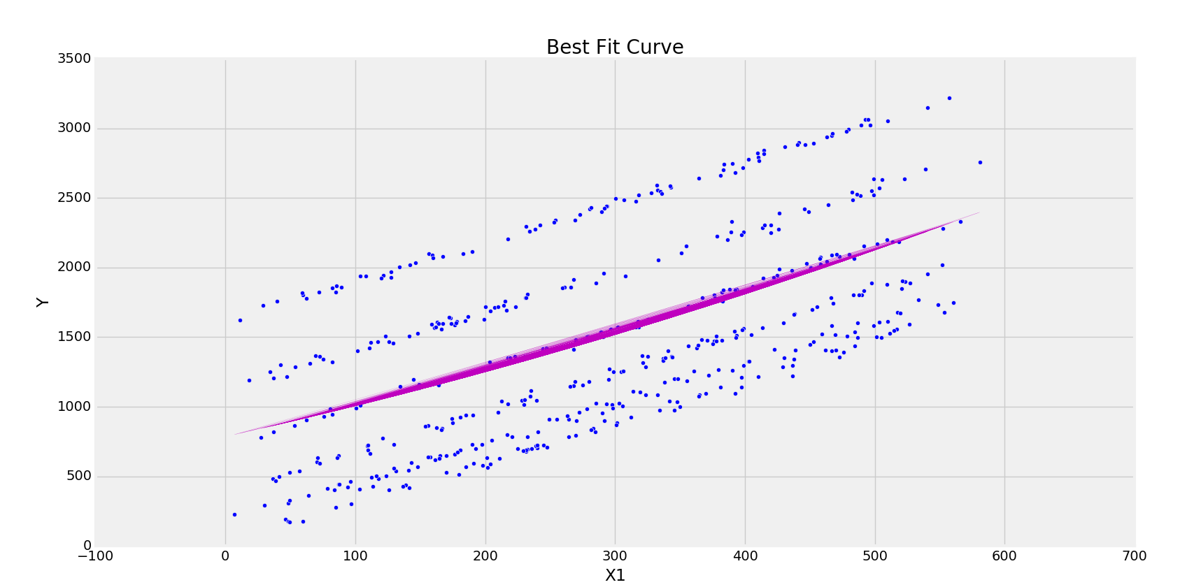

We shall try with a 3rd order polynomial and analyze the statistics

Summary is as follows

-------------------------Summary of Regression Analysis-------------------------

Formula: Y ~ <X1_cube> + <X1_sq> + <X1> + <intercept>

Number of Observations: 500

Number of Degrees of Freedom: 4

R-squared: 0.3556

Adj R-squared: 0.3517

Rmse: 544.0310

F-stat (3, 496): 91.2533, p-value: 0.0000

Degrees of Freedom: model 3, resid 496

-----------------------Summary of Estimated Coefficients------------------------

Variable Coef Std Err t-stat p-value CI 2.5% CI 97.5%

--------------------------------------------------------------------------------

X1_cube -0.0000 0.0000 -1.07 0.2871 -0.0000 0.0000

X1_sq 0.0092 0.0076 1.21 0.2272 -0.0057 0.0241

X1 0.1481 1.9548 0.08 0.9396 -3.6833 3.9795

intercept 900.5107 143.3041 6.28 0.0000 619.6347 1181.3867

---------------------------------End of Summary---------------------------------

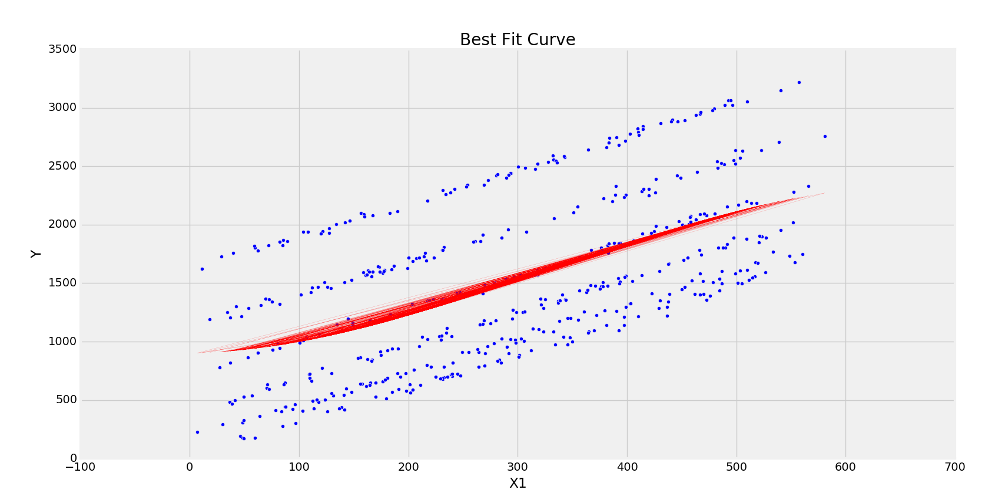

The model is still not improving, with standard error for X1 going very high. Also the p-values for these intercept are representing that the model is getting worse.

**2.8 Overall Comments:**

For Linear Fit

X1 alone provides a bad predictor model. The R_squared value is quite low and standard error in X1 is also high to be considered as the best model.

The residuals do not have a normal distribution and show multi-modal behavior. This can be seen using Q-Q plots and histograms.

For Polynomial Fit

X1^2 and X1^3 both fail to improve the model and cannot provide any better fit or prediction model. In fact, the standard errors for the predictor variables is increased with polynomial fit clearly indicating that the model gets worse with increasing order of X1. Also, the p values start getting out of significance zone with polynomial fits.

Hence, we need to consider other predictor variables to decide the best regression model for the given data. This analysis is done in multiple linear regression in task 3.

# Task3. Multivariate regression

**3.1 Carry out a multiple regression on all the independent variables, and determine the values for all the coefficients, and σ 2**

Using pandas.stats library in python following summary is presented for the model with multivariate linear regression

-------------------------Summary of Regression Analysis-------------------------

Formula: Y ~ <X1> + <X2> + <X3> + <X4> + <X5> + <intercept>

Number of Observations: 500

Number of Degrees of Freedom: 6

R-squared: 0.9988

Adj R-squared: 0.9987

Rmse: 23.9039

F-stat (5, 494): 79644.5847, p-value: 0.0000

Degrees of Freedom: model 5, resid 494

-----------------------Summary of Estimated Coefficients------------------------

Variable Coef Std Err t-stat p-value CI 2.5% CI 97.5%

--------------------------------------------------------------------------------

X1 2.7693 0.0126 220.29 0.0000 2.7447 2.7940

X2 2.4599 3.1537 0.78 0.4358 -3.7214 8.6411

X3 4.7774 11.6047 0.41 0.6808 -17.9678 27.5226

X4 4.4627 0.0436 102.36 0.0000 4.3772 4.5481

X5 5.8932 0.5156 11.43 0.0000 4.8826 6.9038

--------------------------------------------------------------------------------

intercept -1.7921 5.6475 -0.32 0.7511 -12.8612 9.2771

---------------------------------End of Summary---------------------------------

Values of all coefficients are as shown in the table above.

Coefficient of X1 = 2.7693

Coefficient of X2 = 2.4599

Coefficient of X3 = 4.7774

Coefficient of X4 = 4.4627

Coefficient of X5 = 5.8932

Intercept = -1.7921

RMSE presented by the summary is 23.9039

From the summary we have the following observations:

R-squared value is very high which is indicative of good fit of the model. But it can also be a case of overfitting. As we can see, the p-values for X2 and X3 are very high which clearly indicates that the model is bad with all the variables included. The standard error in these independent variables (X2 and X3) is also very high. Overall, the model looks very promising with following values on residual analysis

MultiVariate Linear regresssion model X1,X2,X3,X4,X5, Y

s_square= 564.540245174

RMSE= 23.8077188129

R_squared: 0.998761025577

Critical value for Chi-squared test: 37.8280426087

Critical value: 42.5569678043

Graphically too, it appears to be an excellent regression model. But due to the reasons indicated above and observing correlation matrix, we can say that it is case of overfitting.

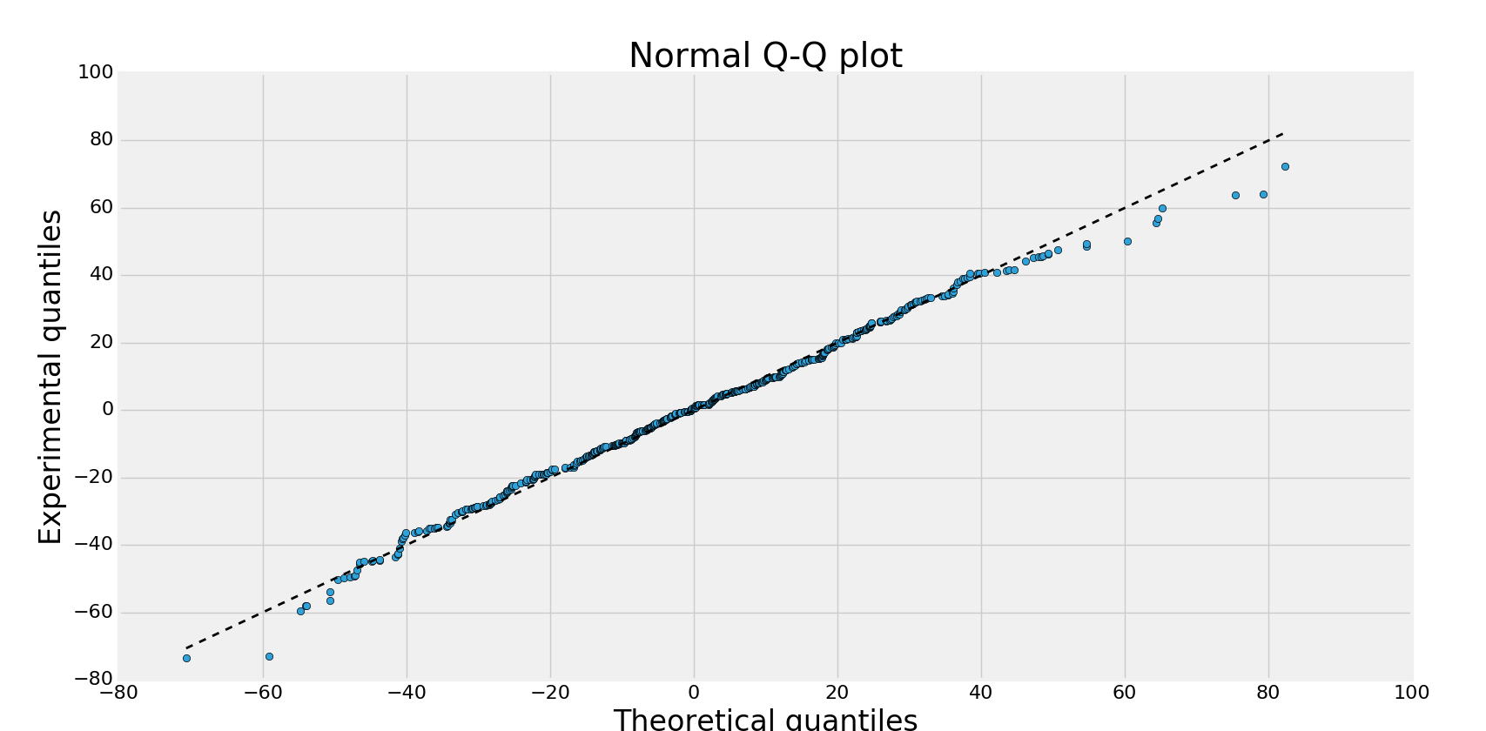

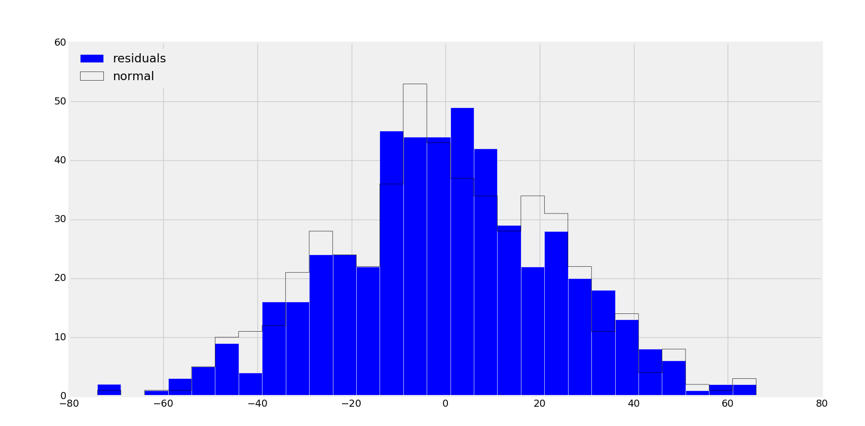

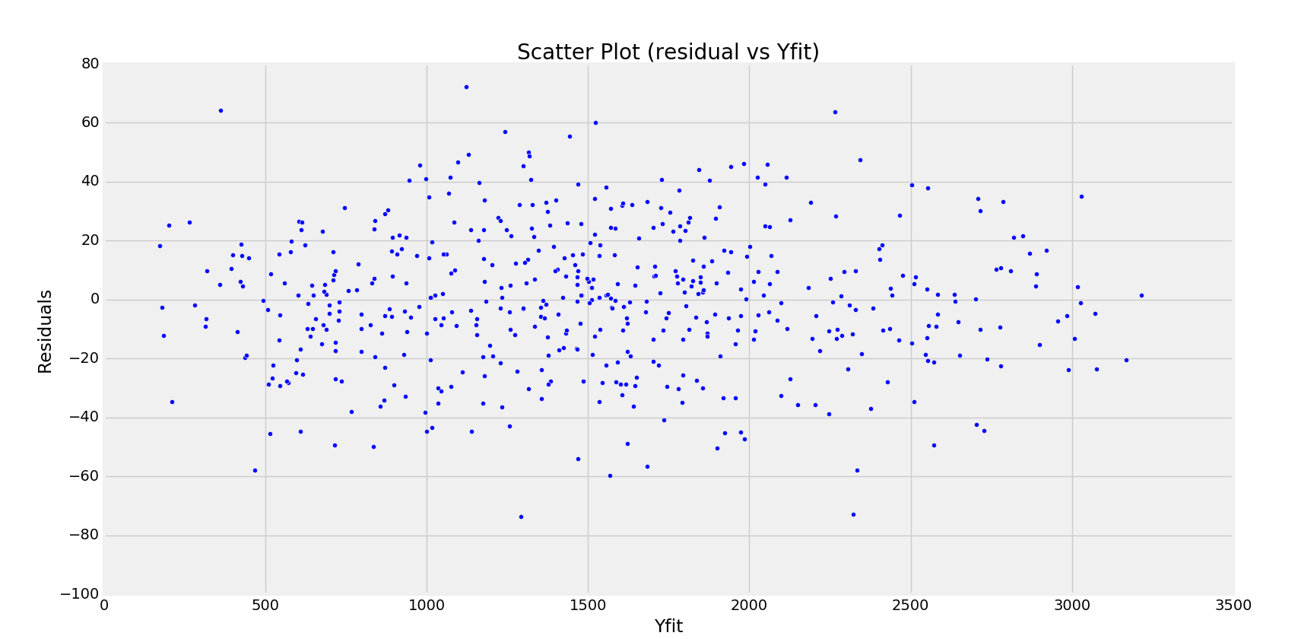

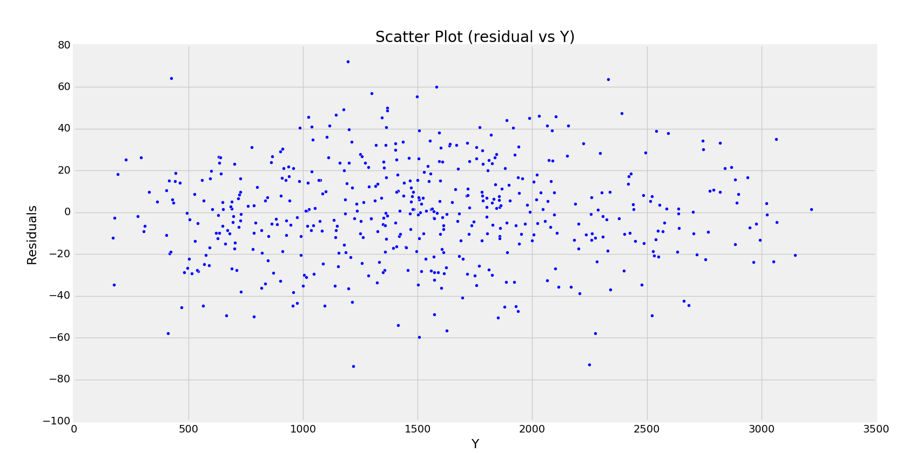

**3.2 Based on the p-values, R2 , F value, and correlation matrix Σ, identify which independent variables need to be left out (if any) and go back to step 3.1**

**3.3 Do a residual analysis:**

**a. Do a Q-Q plot of the pdf of the residuals against N(0, s 2 ). Alternatively, draw the residuals histogram and carry out a χ 2 test that it follows the N(0, s 2 ).**

**b. Do a scatter plot of the residuals to see if there are any correlation trends.**

Based on the above observation of R_sq, the model looks very promising and good fit but high values of p values (beyond significance zone) for X2 and X3 indicate that model might be better off even without their contribution.

Now let us see the correlation matrix from task 1 once again



Here, X3 is not correlated to Y. So it may be an additional entry without contributing to the regression model. It may be causing the problem of overfitting. So we should drop X3 predictor variable

Other predictor variables i.e. X1, X2, X4 and X5 have a fairly high correlation with the response variable Y. So their contribution can be significant in predicting Y.

Also it can be seen that X1 and X5 are highly correlated (0.808) and similarly X2-X4 have a high correlation (0.979). So their mutual correlation may cause the issue of multi collinearity. As a precaution for our best prediction model, we will need to drop one variable from each of the two pairs.

Let’s do it step by step.

First, we will analyze the model without X3. Then we can test the model by dropping some variables that are correlated with other variables. Let’s follow the following order and predict the best model.

1. Drop X3. Use X1, X2, X4 and X5
2. Use X1,X2
3. Use X1,X4
4. Use X2,X5
5. Use X4,X5
6. **Drop X3, Use X1,X2,X4,X5**

Perform multivariate regression

-------------------------Summary of Regression Analysis-------------------------

Formula: Y ~ <X1> + <X2> + <X4> + <X5> + <intercept>

Number of Observations: 500

Number of Degrees of Freedom: 5

R-squared: 0.9988

Adj R-squared: 0.9988

Rmse: 23.8838

F-stat (4, 495): 99723.0057, p-value: 0.0000

Degrees of Freedom: model 4, resid 495

-----------------------Summary of Estimated Coefficients------------------------

Variable Coef Std Err t-stat p-value CI 2.5% CI 97.5%

--------------------------------------------------------------------------------

X1 2.7694 0.0126 220.52 0.0000 2.7448 2.7940

X2 2.5228 3.1473 0.80 0.4232 -3.6460 8.6916

X4 4.4618 0.0435 102.53 0.0000 4.3765 4.5471

X5 5.8899 0.5151 11.43 0.0000 4.8803 6.8996

intercept -1.4444 5.5793 -0.26 0.7958 -12.3798 9.4911

---------------------------------End of Summary-------------------------------

**Comments:** The model is still good without X3. So it can be dropped

But p value for X2 is outside the significance zone. Also, its standard error is high. X5 also has high standard error. It shows that we can have a better model without X2 and X5.

Let’s perform a residual analysis in this case

Linear regresssion model X1,X2,X4,X5, Y

s_square= 564.734001975

RMSE= 23.8118040059

R_squared: 0.998760600347

Critical value for Chi-squared test: 40.6120064988

Critical value: 42.5569678043

The residual fits pretty well with normal distribution. It can be seen through plots too

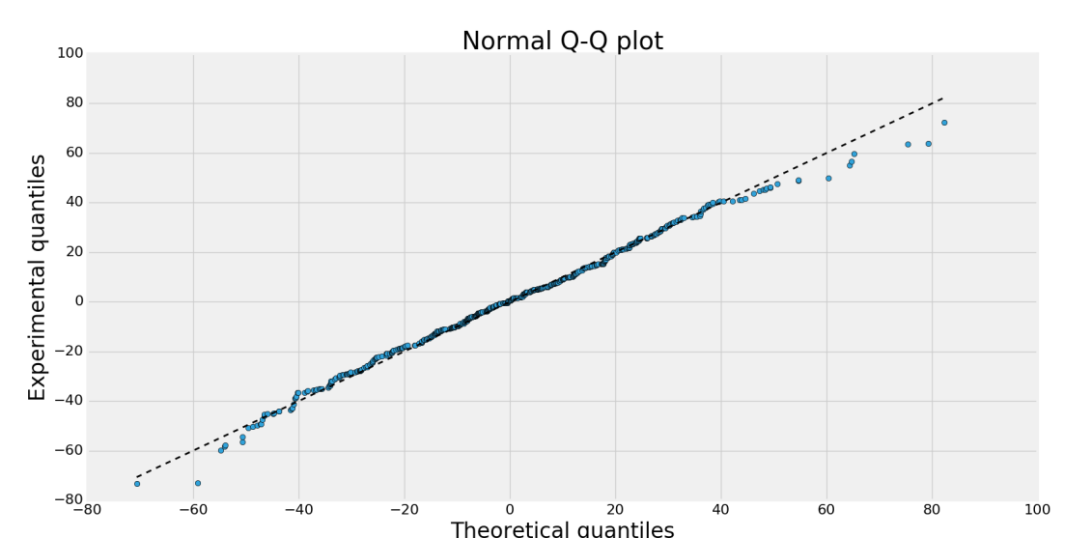

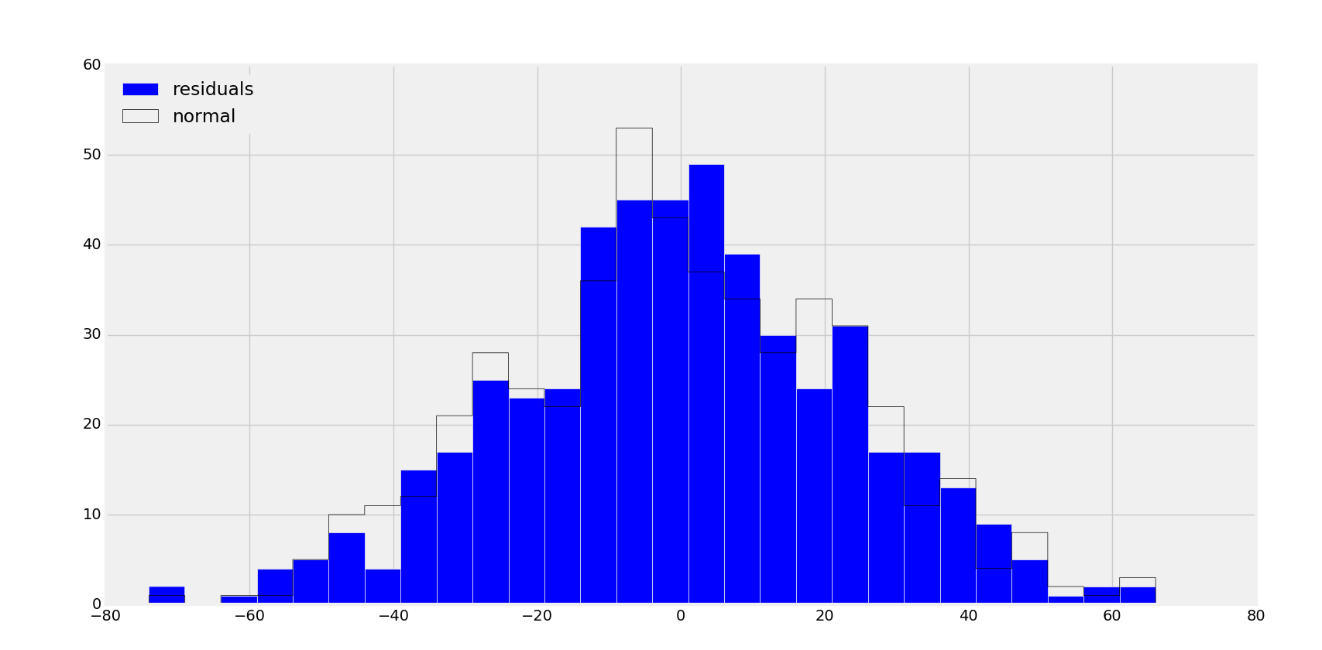

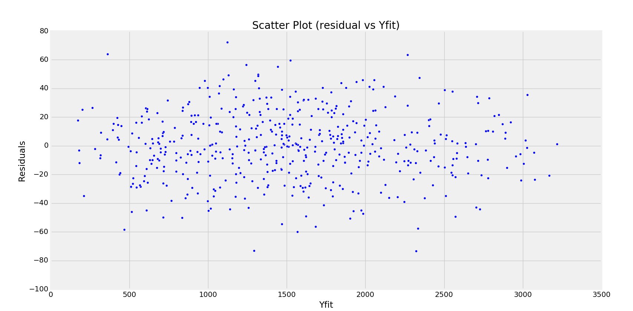

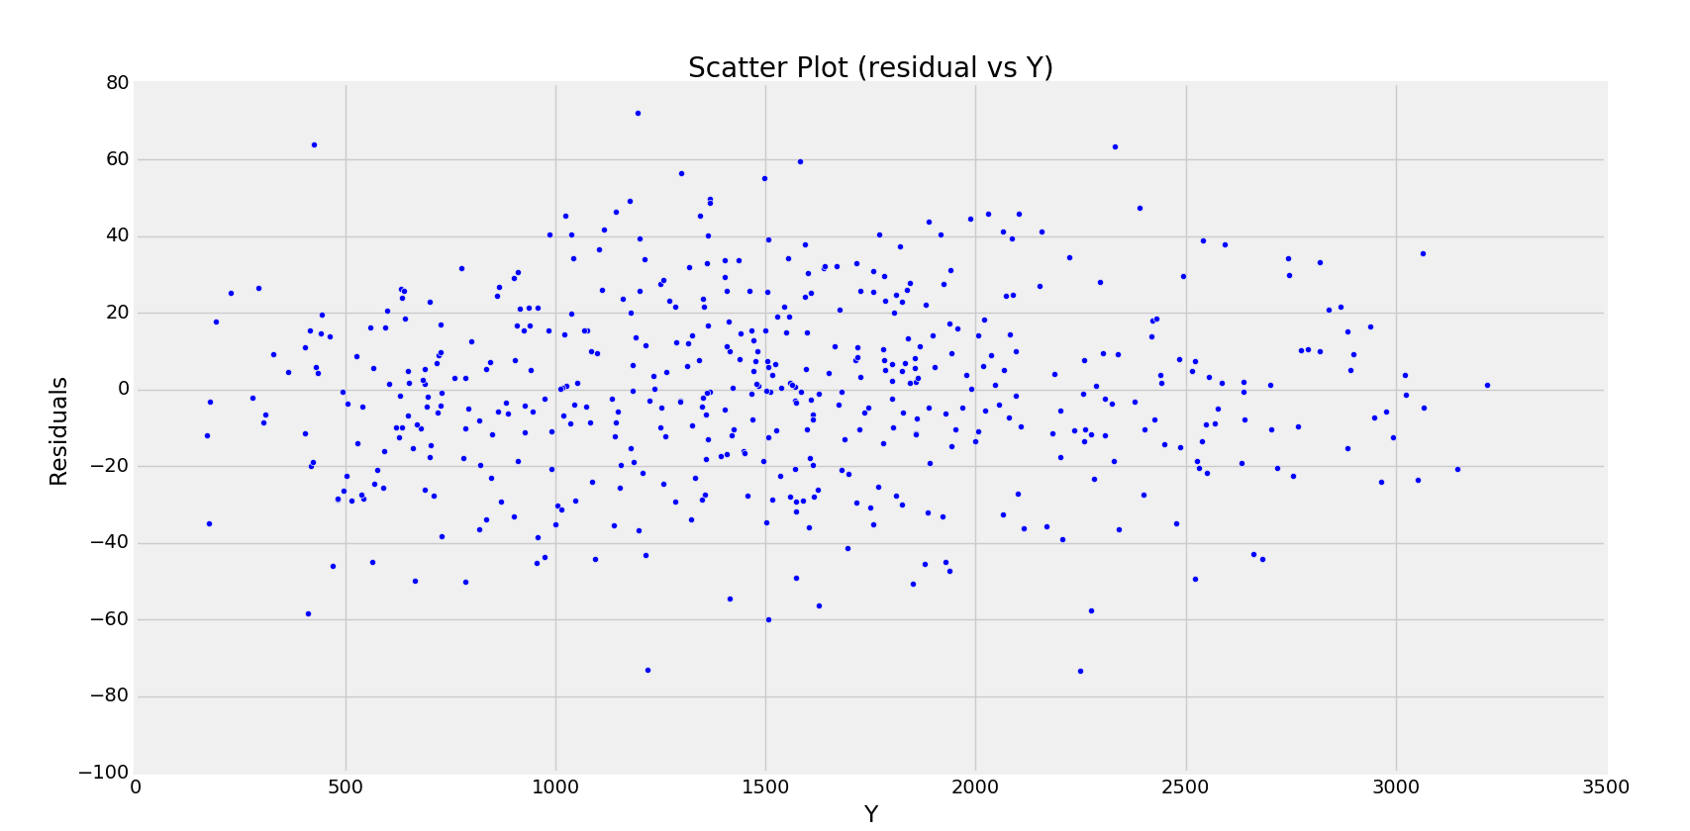

Scatter plots show no correlation trends

1. **Use X1,X2 (correlation -0.028)**

-------------------------Summary of Regression Analysis-------------------------

Formula: Y ~ <X1> + <X2> + <intercept>

Number of Observations: 500

Number of Degrees of Freedom: 3

R-squared: 0.9721

Adj R-squared: 0.9720

Rmse: 113.1310

F-stat (2, 497): 8651.9033, p-value: 0.0000

Degrees of Freedom: model 2, resid 497

-----------------------Summary of Estimated Coefficients------------------------

Variable Coef Std Err t-stat p-value CI 2.5% CI 97.5%

--------------------------------------------------------------------------------

X1 2.8742 0.0350 82.20 0.0000 2.8057 2.9428

X2 318.7123 3.0359 104.98 0.0000 312.7620 324.6627

intercept -450.6407 15.8381 -28.45 0.0000 -481.6834 -419.5980

---------------------------------End of Summary---------------------------------

**Comments:** R_sq value has slightly reduced but still a good fit. p-value for X1 and X2 are inside significance zone. But since we see the Std error for X2 is still high we can use some other predictor variable.

Let’s perform the residual analysis.

Linear regresssion model X1, Y

s_square= 12721.8208115

RMSE= 113.01731045

R_squared: 0.972079916834

Critical value for Chi-squared test: 441.375194177

Critical value: 42.5569678043

Using R_square, the fit appears to be fine but, the normal distribution of residuals is highly distorted (We can say that using chi_sq values). So this model should be rejected

Let’s see the plots

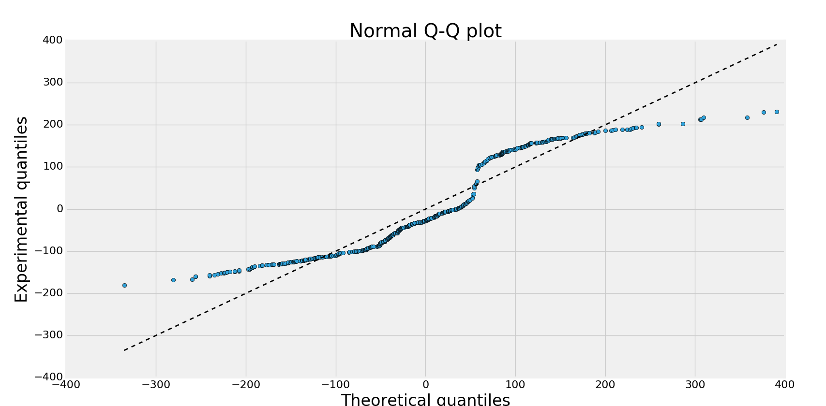

Clearly, Q-Q plot shows the bi-modal behavior and hence the residuals in our models do not represent the normal distribution. It can be further seen using histogram

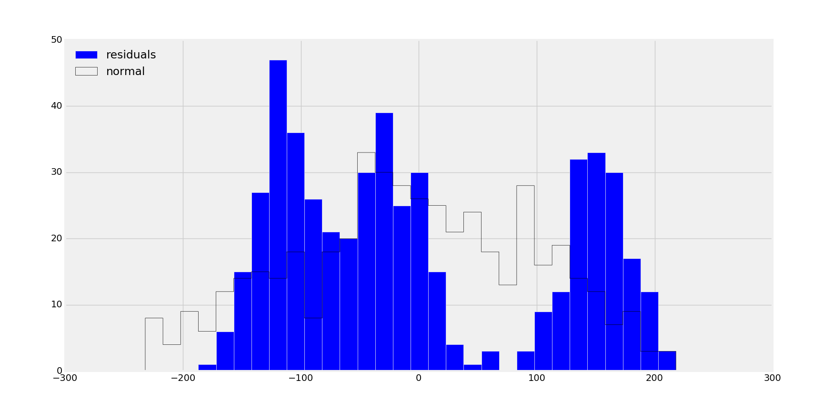

Following are the scatter plots for the residuals

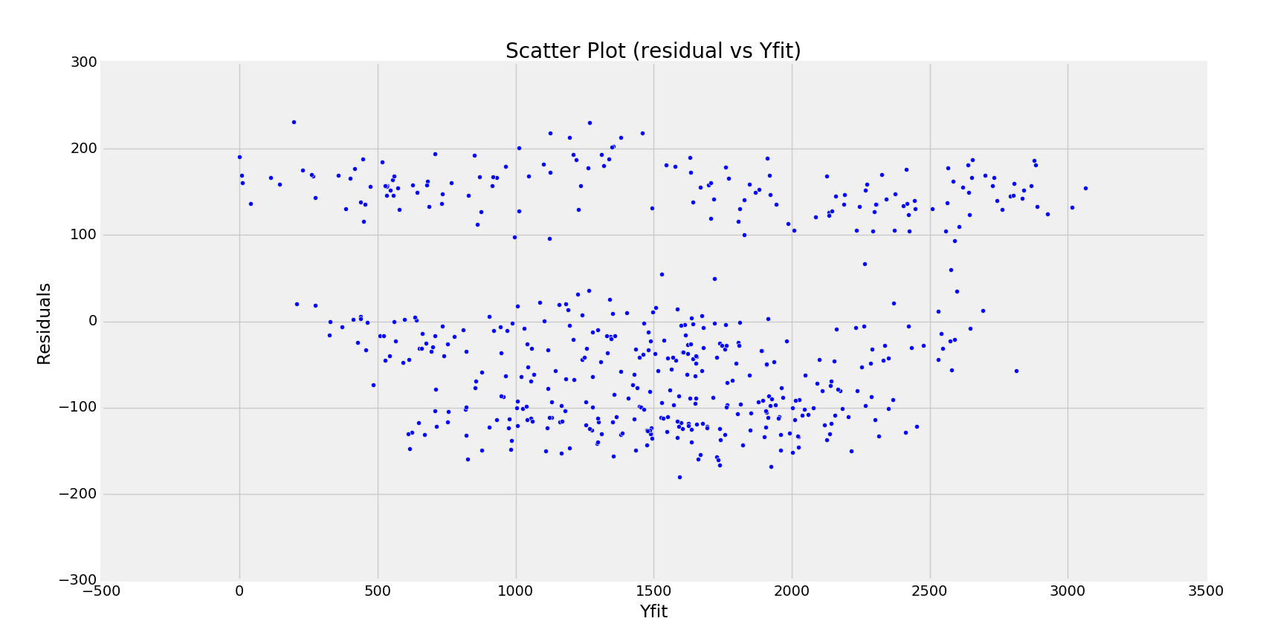

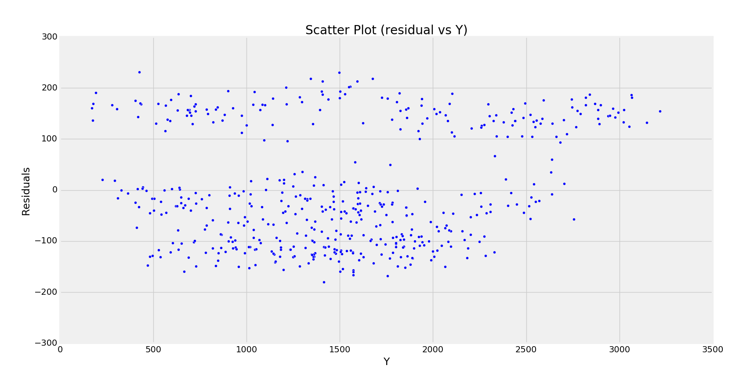

Scatter plots however, do not show any correlation trends

1. **Using X2,X5 (Correlation -0.003)**

Summary

-------------------------Summary of Regression Analysis-------------------------

Formula: Y ~ <X2> + <X5> + <intercept>

Number of Observations: 500

Number of Degrees of Freedom: 3

R-squared: 0.8521

Adj R-squared: 0.8515

Rmse: 260.3641

F-stat (2, 497): 1431.8914, p-value: 0.0000

Degrees of Freedom: model 2, resid 497

-----------------------Summary of Estimated Coefficients------------------------

Variable Coef Std Err t-stat p-value CI 2.5% CI 97.5%

--------------------------------------------------------------------------------

X2 312.4168 6.9842 44.73 0.0000 298.7278 326.1058

X5 97.5023 3.3011 29.54 0.0000 91.0320 103.9725

intercept 118.1945 29.0988 4.06 0.0001 61.1607 175.2282

---------------------------------End of Summary---------------------------------

**Comments:** R_squared values have reduced and hence it can be concluded that, this model does not give a good fit for the predictor when compared with previous models. Also, the standard error for coefficients has increased. So we will reject this model

Let’s perform the residual analysis for this model

Linear regresssion model X1, Y

s_square= 67382.7162153

RMSE= 260.102536576

R_squared: 0.852117784979

Critical value for Chi-squared test: 43.563257628

Critical value: 42.5569678043

**Comments:** Using the chi_squared test, here we should reject the hypothesis for normal distribution of the residuals. But it is quite close to normal distribution hypothesis and can be seen in the plots too. But due to the above mentioned reasons, we will reject this hypothesis

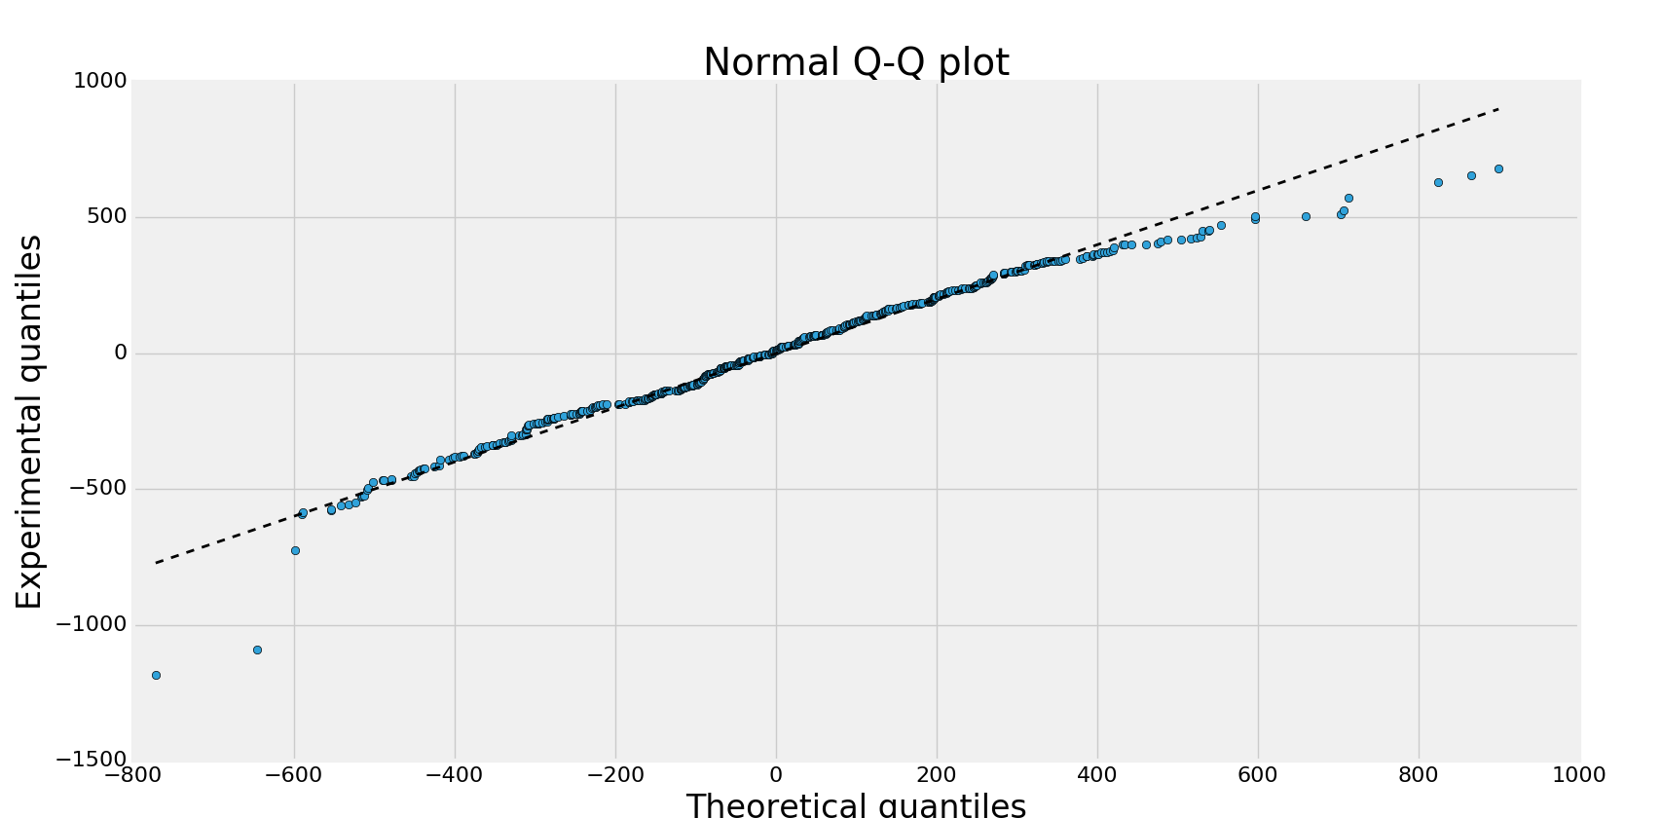

Q-Q plot has a long tail. Possibly, that is causing the deviation from normal behavior

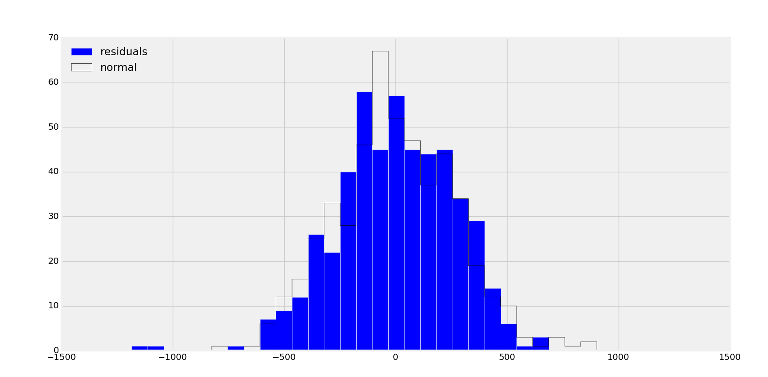

The histogram shows skewness in the residual model

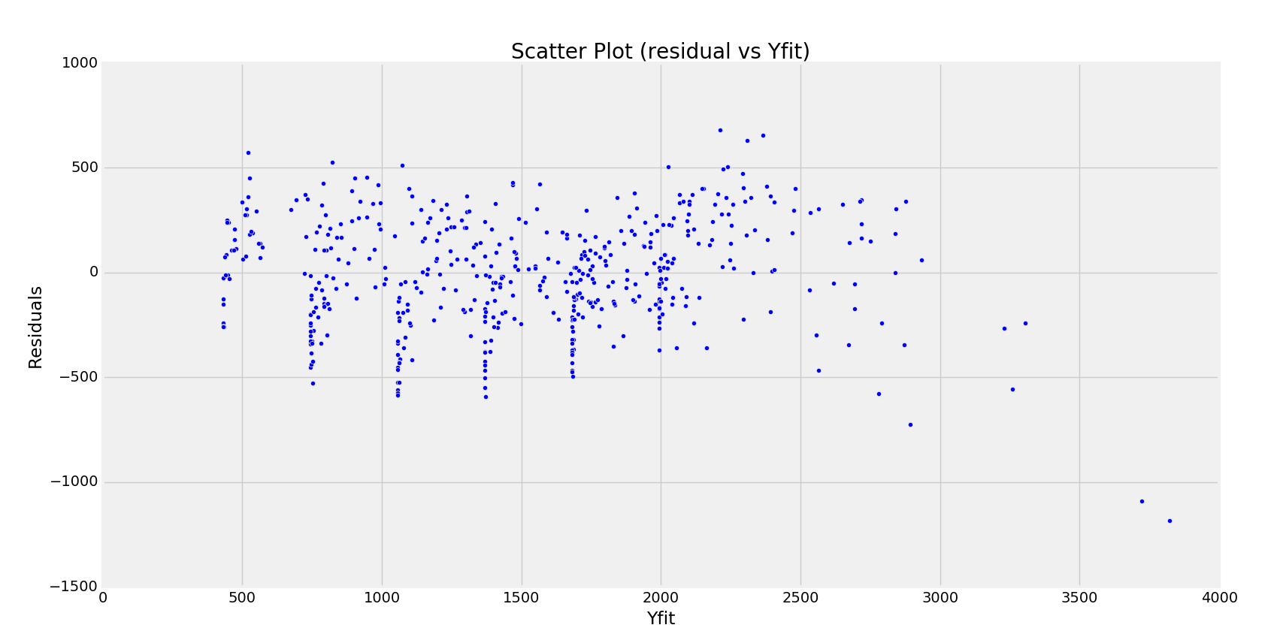

Scatter plot shows no correlation but more values are concentrated in the positive side.

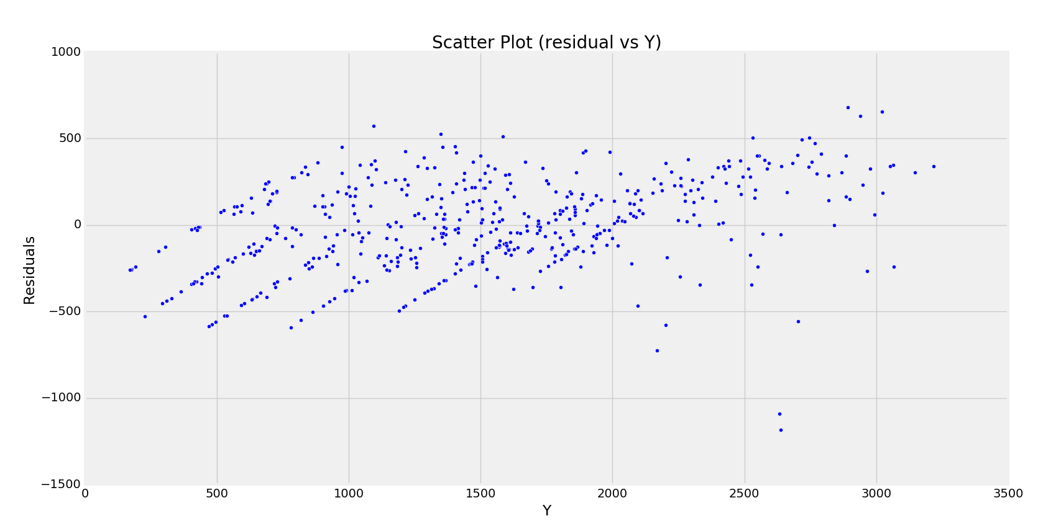

1. **X4,X5 (Correlation -0.005422)**

Summary

-------------------------Summary of Regression Analysis-------------------------

Formula: Y ~ <X4> + <X5> + <intercept>

Number of Observations: 500

Number of Degrees of Freedom: 3

R-squared: 0.8770

Adj R-squared: 0.8765

Rmse: 237.4522

F-stat (2, 497): 1771.8196, p-value: 0.0000

Degrees of Freedom: model 2, resid 497

-----------------------Summary of Estimated Coefficients------------------------

Variable Coef Std Err t-stat p-value CI 2.5% CI 97.5%

--------------------------------------------------------------------------------

X4 4.4085 0.0881 50.06 0.0000 4.2359 4.5811

X5 97.7841 3.0107 32.48 0.0000 91.8832 103.6850

intercept 548.3237 19.3984 28.27 0.0000 510.3028 586.3447

---------------------------------End of Summary---------------------------------

**Comments:** R_squared value is decreased. Also the standard error for X5 is still high. So we reject this model

Let’s do the residual analysis

Linear regresssion model X4,X5 Y

s_square= 56045.2580913

RMSE= 237.213699961

R_squared: 0.876999661434

Critical value for Chi-squared test: 32.7067070007

Critical value: 42.5569678043

The residual analysis gives a match to a fairly normal distribution for the residuals. It can be seen from the plots as well

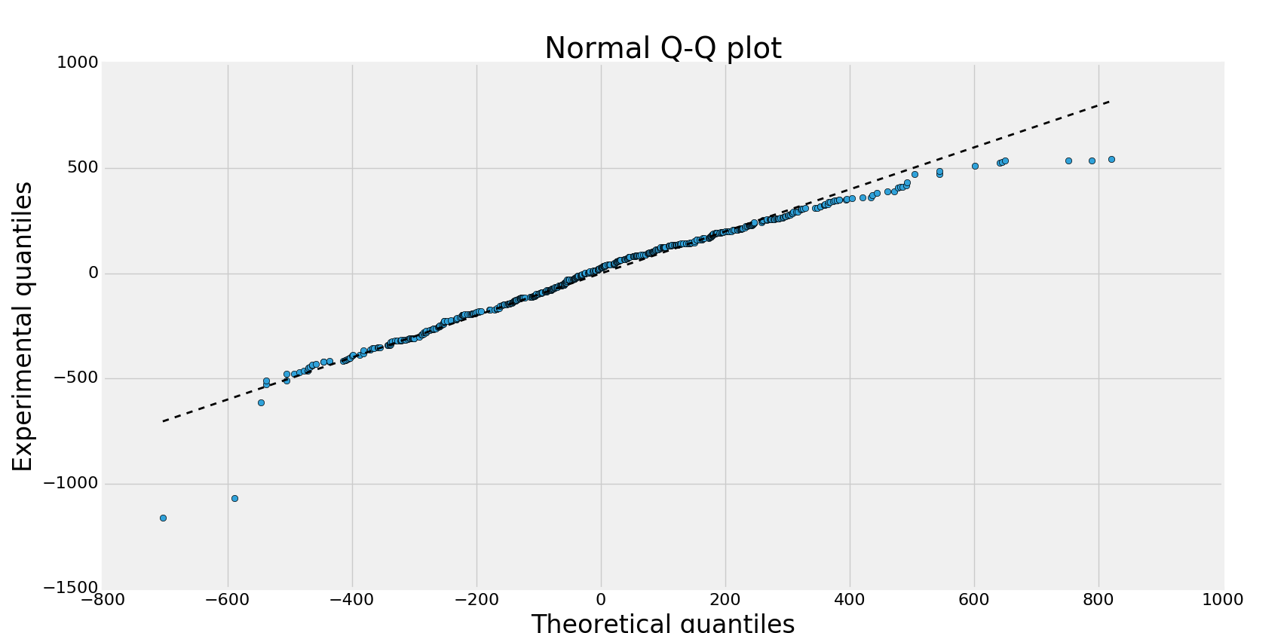

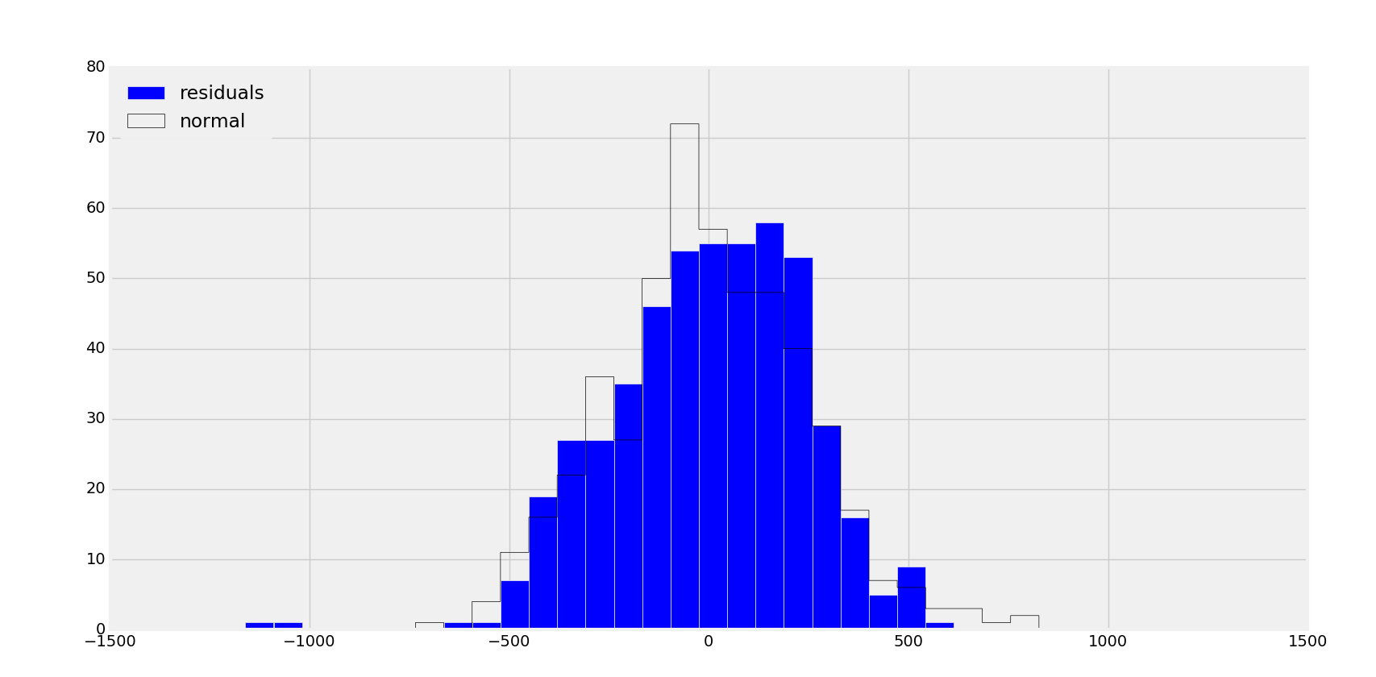

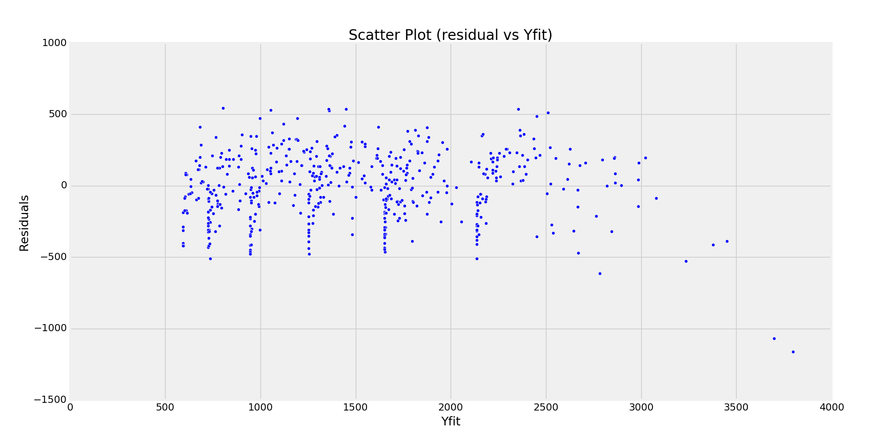

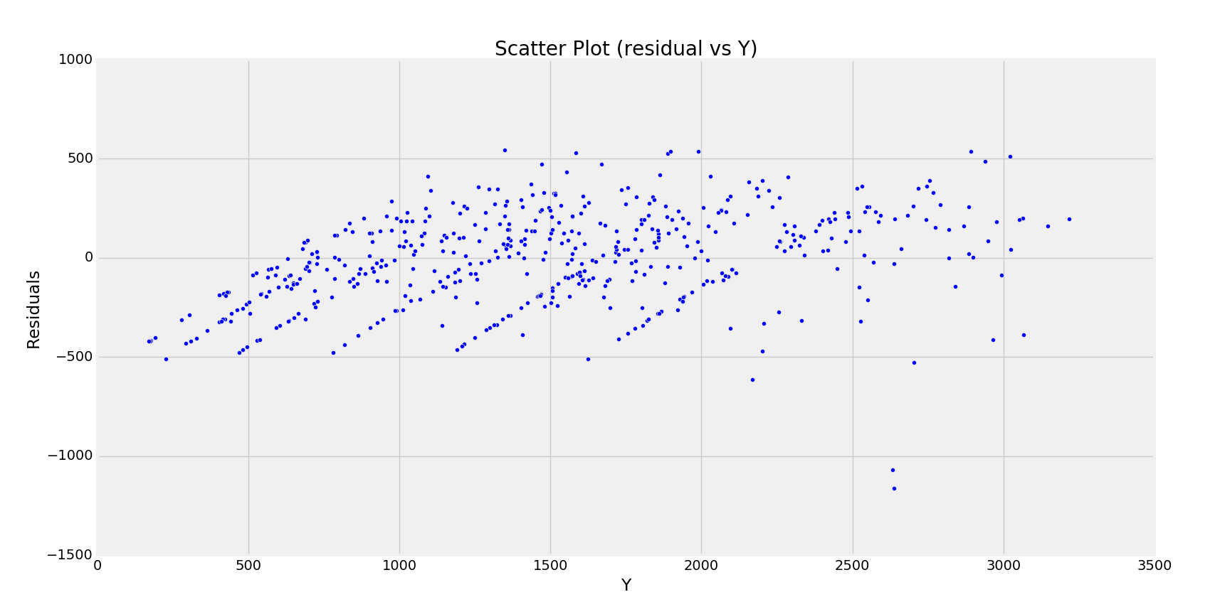

1. **X1,X4 (Correlation -0.030691)**

-------------------------Summary of Regression Analysis-------------------------

Formula: Y ~ <X1> + <X4> + <intercept>

Number of Observations: 500

Number of Degrees of Freedom: 3

R-squared: 0.9984

Adj R-squared: 0.9984

Rmse: 26.8136

F-stat (2, 497): 158190.0479, p-value: 0.0000

Degrees of Freedom: model 2, resid 497

-----------------------Summary of Estimated Coefficients------------------------

Variable Coef Std Err t-stat p-value CI 2.5% CI 97.5%

--------------------------------------------------------------------------------

X1 2.8856 0.0083 348.15 0.0000 2.8694 2.9019

X4 4.4993 0.0099 452.26 0.0000 4.4798 4.5188

intercept -14.6123 3.1286 -4.67 0.0000 -20.7444 -8.4802

---------------------------------End of Summary---------------------------------

**Comments:** This y model has a high R_squared value. Also, it has p-values for X1 and X4 within zone of significance and also standard erros for independent variables is highly reduced. F value is also high and over all p value is also less. Hence this is the best model for our data and **this model should be accepted as the predictor model**

Let’s do the residual analysis for this model

Linear regresssion model X1,X4, Y

s_square= 714.658034604

RMSE= 26.8136507361

R_squared: 0.998431567929

Critical value for Chi-squared test: 30.102949885

Critical value: 42.5569678043

Clearly, the chi_squared value lies well below critical value and hence the hypothesis that the residuals have a normal distribution holds true. Also, this can be seen using the plots

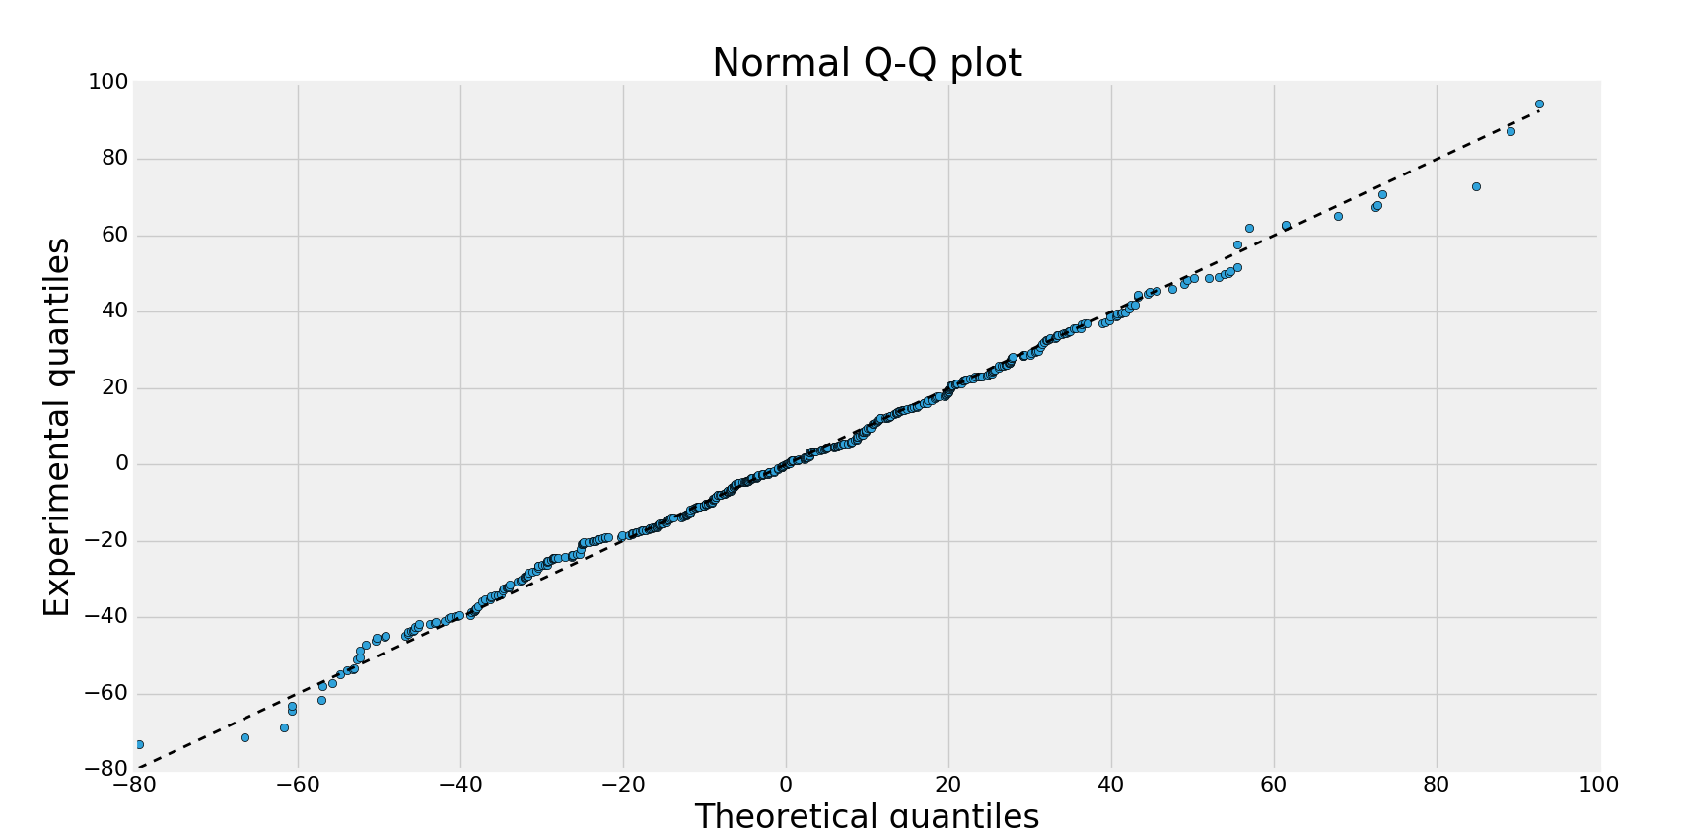

From Q-Q plot and histograms it follows that residuals have a normal distribution

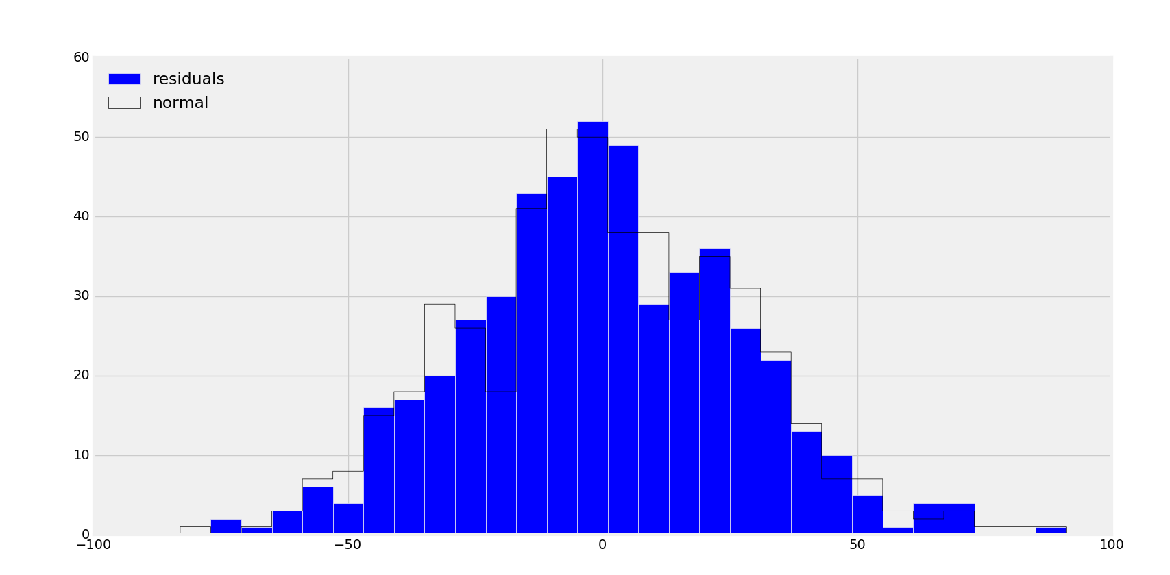

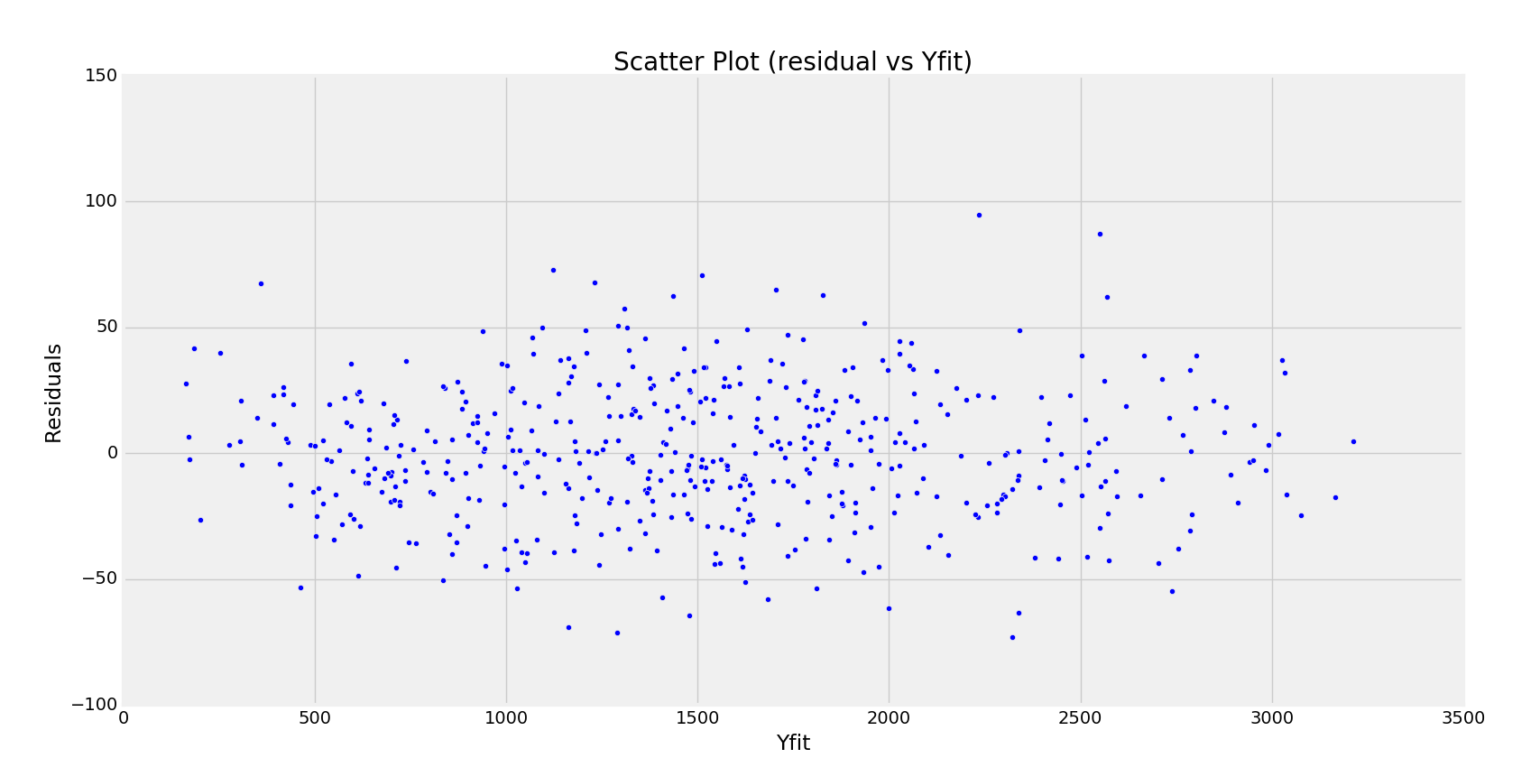

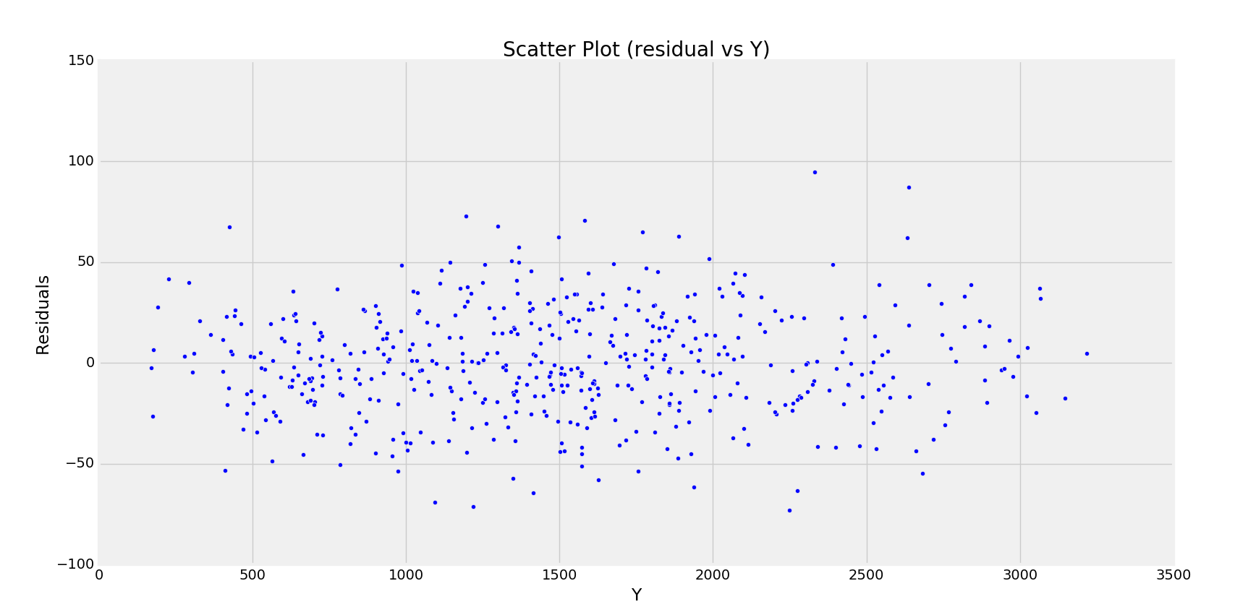

Also, the scatter plots for the residuals average out to zero with no correlation trends.

**Hence, this is the best regression model for the given data (consists of predictor variables X1 and X4)**